*Business Hub Email Blast Corrections*



In this section only use the points mentioned below & exclude other.

A fixed-tax regime where taxes are being calculated on per square feet bases

• No bifurcation of plots and constructed property for determining holding period for CGT collection

• Properties’ holding period for CGT imposition reduced to 4 years

• CGT percentage on immovable property reduced to 7.5% if sold within 2 years of purchase, 50% in case a unit is sold within 3 years, 2.5% if sold within 4 years

• No CGT applicable on immovable properties sold after 4 years

• Advance Tax on property sales reduced to 5%

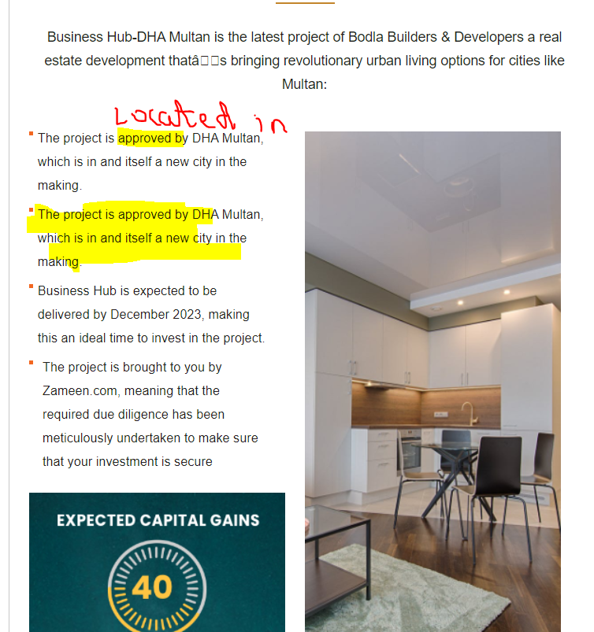

Change approved by with “Located in” & same point has mentioned twice.

Exchange the 2nd point with the below mentioned point:

“The exemplary location of Business Hub - the first mega mall of DHA Multan - makes it an ideal investment for retailers and business owners alike.”

Also add point in this section mentioned below:

* Business Hub offers 10% discount on upfront payment and 5 % discount on half payment.



Use the updated construction update video for the month of June & correct the spellings of “**Centre”**